**Install R and RStudio (Posit):**

1. Please download and install R from here: <https://cran.r-project.org/bin/windows/base/> (use <https://cran.r-project.org/> for Mac)
2. Click the large link at the top "Download R-4.X.X for Windows" to start the download and then install it.
3. Once R is installed, please download RStudio (now called Posit) from here: <https://posit.co/download/rstudio-desktop/>

**Save your files:**

* + - 1. To ensure RStudio can access the files it needs, make sure that you save your data file and the RStudio file into the **same** folder on your computer.
      2. Download:
         1. the RStudio file (For Mac: Mac_FloweringPlantsMarkdown.qmd; for PC: PC_FloweringPlantsMarkdown.qmd) and save to your desired file storage location.
         2. The Excel datasheet and save to the **same** location as the .qmd file.

**Edit your Wildflower data Excel file:**

Open up the excel file and adjust the flower names and bloom times to align with your data.

Make note of which of the rows and columns contain your data (e.g., rows 3-11 and columns 1-3).

Save the file.

**Open RStudio:**

1. When you are done with the downloads and installations, open up RStudio on your computer:

|  |
| --- |
| When you start RStudio, you’ll see four key regions or “panes” in the interface: the Source pane, the Console pane, the Environment pane and the Output Pane. RStudio Panes  1. The **Source pane** is where you can edit and save R or Python scripts or author computational documents like Quarto and R Markdown. 2. The **Console pane** is used to write short interactive R commands. 3. The **Environment pane** displays temporary R objects as created during that R session. 4. The **Output pane** displays the plots, tables, or HTML outputs of executed code along with files saved to disk.   A screenshot of the RStudio UI. There are 4 primary panes, the source, console, environment, and output panes.  Taken from: <https://docs.posit.co/ide/user/ide/get-started/> |

**Open Script for Wildflower Watch data**: You will open and run a file that will allow you to call your data from the excel file and create a plot of that data in RStudio.

1. **Open the RStudio .qmd file in Rstudio** (File 🡪 Open File).
   1. For Mac users, use this file: Mac_FloweringPlantsMarkdown.qmd
   2. For PC users, use this file: PC_FloweringPlantsMarkdown.qmd)
2. There are directions embedded into this file, but this will also walk you through the process.

**Run and Edit the script:** There are only a couple of lines that you’ll need to adjust to select the right excel file and ensure the rows/columns are all included.

*Note: Grey boxes are places where to code is written. Other text is information for you telling you what that block of code is doing. Any text after a # is a note about the code that the coder left to provide context for that block of code.*

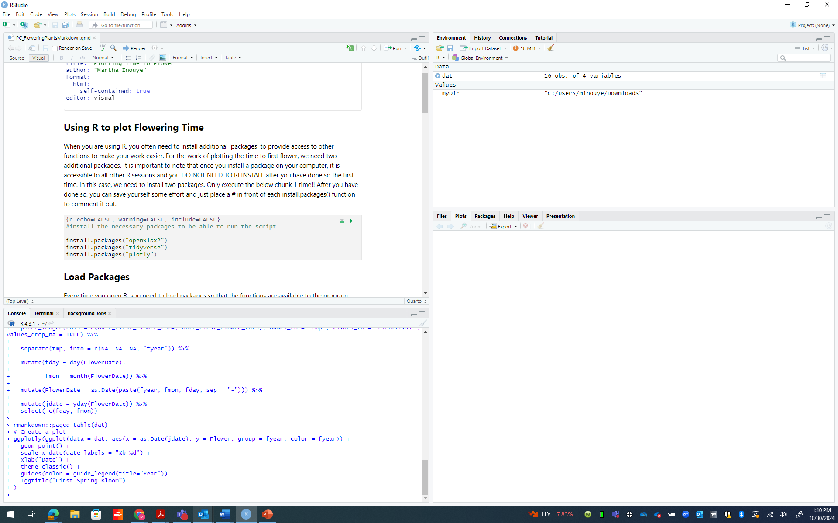

When you are using R, you often need to install additional 'packages' to provide access to other functions to make your work easier. For the work of plotting the time to first flower, we need two additional packages. Once you install a package on your computer, it is accessible to all other R sessions and you DO NOT NEED TO REINSTALL after you have done so the first time.

In this case, we need to install two packages. **Push the green play arrow on the upper right corner of this box.**

Only execute this section one time!! After you have done so, you can save yourself some effort and just place a # in front of each install.packages() function to comment it out.

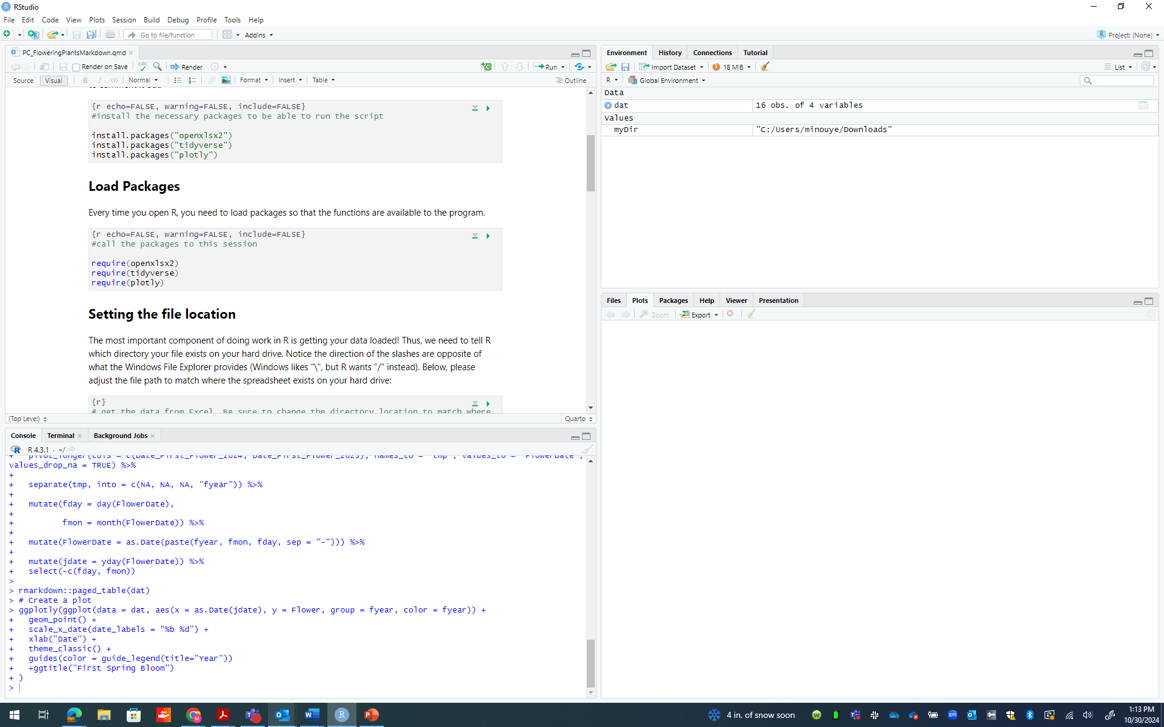

Each time you open RStudio, you will need to load the packages you want to use. This is different than installing them. It just calls these packages to that particular session. That is what this section does.

**Push the green play arrow on the upper right corner of this box** to call the necessary packages to create the plot.

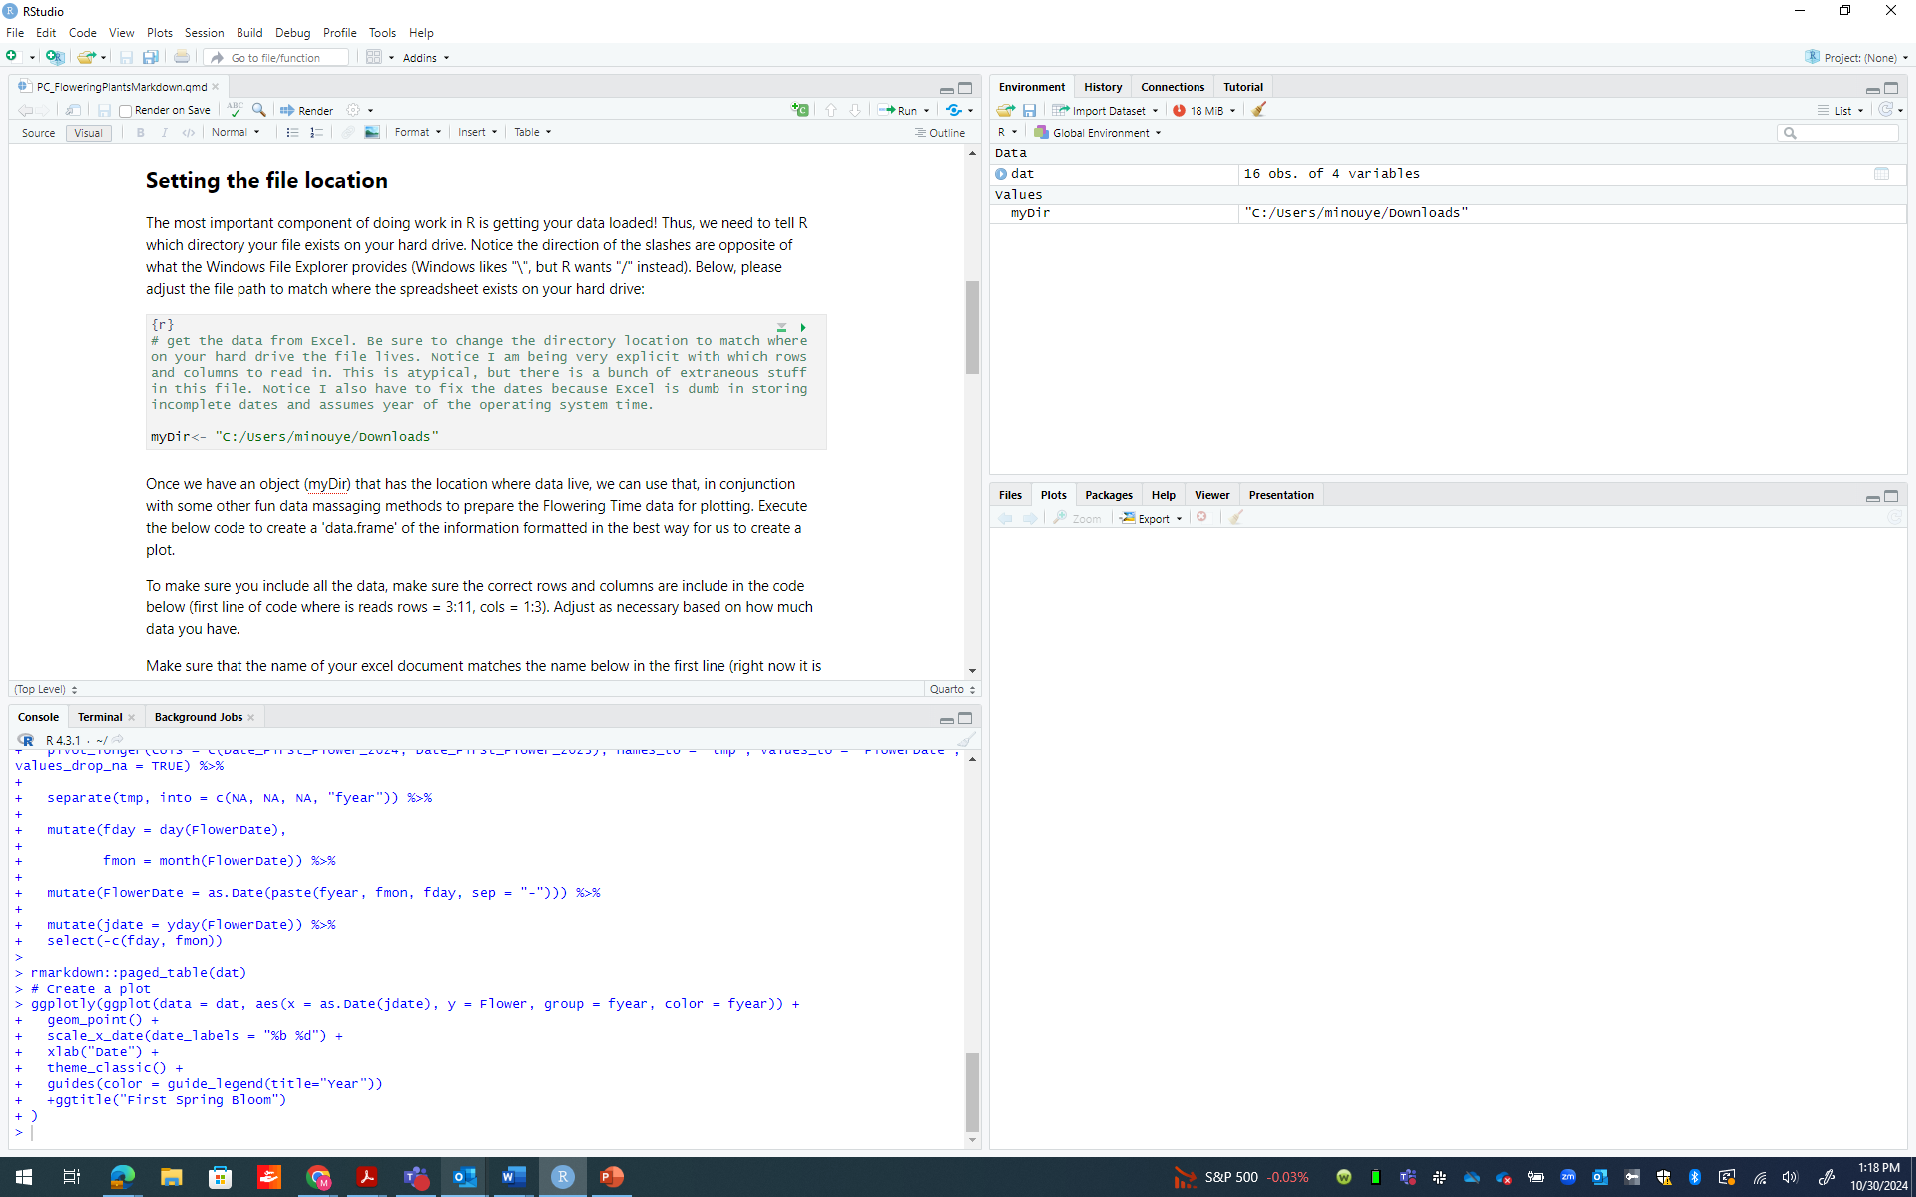

Find the “**Setting the File Location**” section in the code. You will need to adjust one piece of this code to tell RStudio where to find the files on your hard drive.

Adjust the directory location (see what is circled above) to match where your wildflower data excel file is located. To find this, you can look at the properties of your file by opening File Explorer (PC) or Finder (Mac), finding the file, and right clicking to look at the “location” (PC) and “get info” (Mac) section. Make sure to keep the slashes in the code to separate the locations.

Once you adjust the file location, **Push the green play arrow on the upper right corner of this box** to access the excel file.

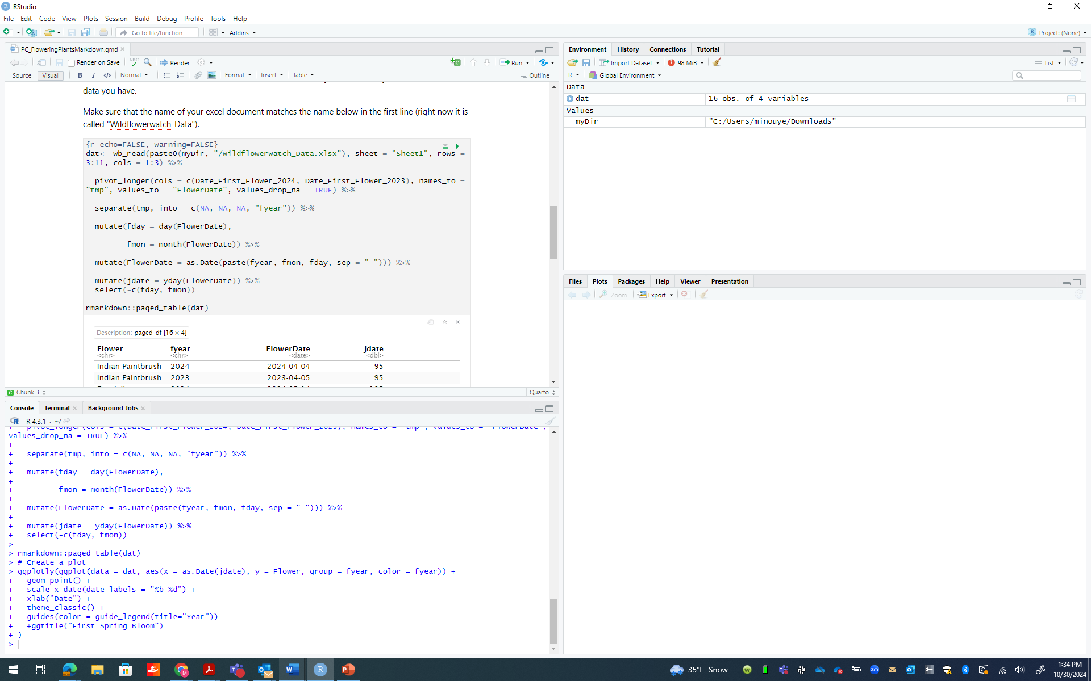

Once you’ve let RStudio access the excel file, we can open the data in RStudio with formatting that helps to plot it. To make sure you include all the data, make sure the correct rows and columns are included in the code (first line of code where is reads rows = 3:11, cols = 1:3). Adjust as necessary based on how much data you have.

Make sure that the name of your excel document matches the name in the first line (right now it is called "Wildflowerwatch_Data").

**Push the green play arrow on the upper right corner of this box** to create a 'data.frame' of the information formatted in the best way to create a plot.

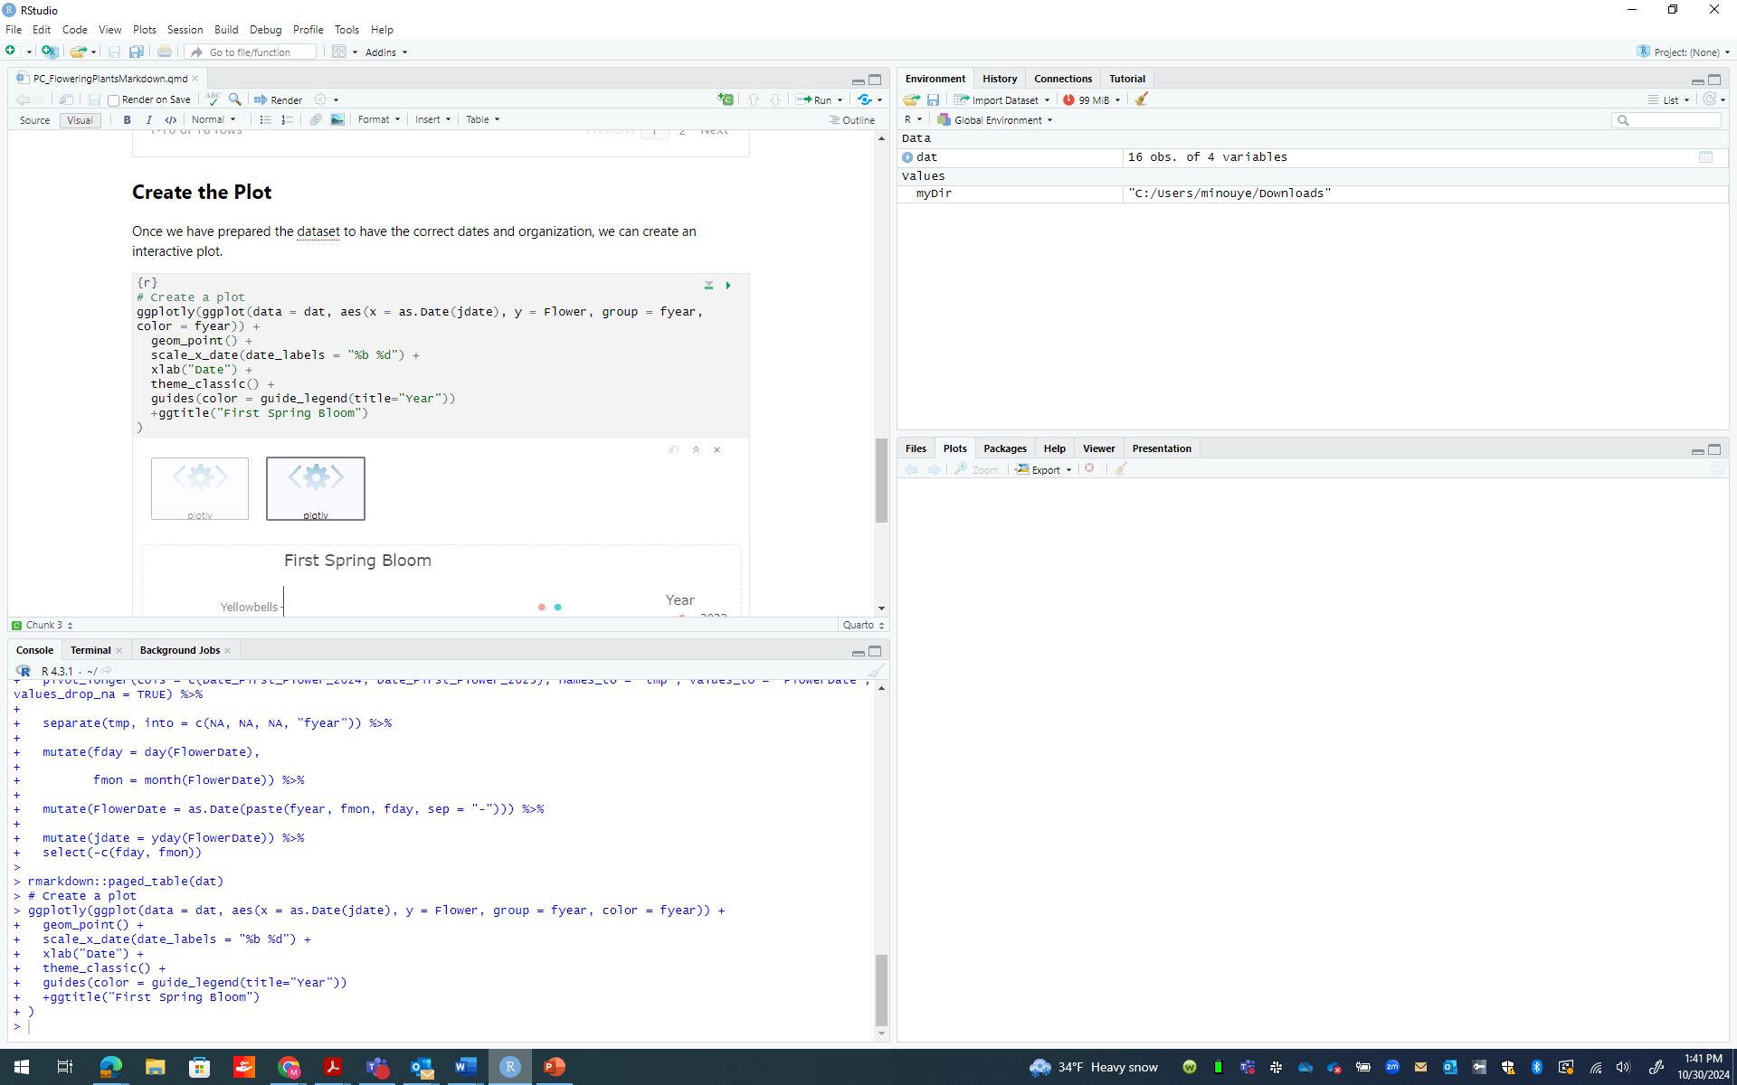

Now you can create your plot! **Push the green play arrow on the upper right corner of this box** to create your plot. The plot should appear below the gray box.

You can export the plot as an image.